| Program Name: | 09_1 |
| --- | --- |
| Roll No: | 1504 |
| Title of Program: | Doubly Linked List |
| Objective: | Code for Doubly Linked list with implementation of:   1. Insert 2. Search 3. Count 4. Display 5. Deletion |

**CODE:**

/*

Name:Aniket Bhure

Roll no: 1504

Unit 4: Lists

Program: Doubly Linked List */

import java.util.Scanner;

/* 1. Node Template */

class DNode{

int data;

DNode right;

DNode left;

/* Constructor */

public DNode(int d)

{

left = null;

data = d;

right = null;

}//End of Constructor

} //end of Node

class Dlist{

DNode head;

DNode tail;

Dlist(){

head = null;

tail = null;

} // end of constructor

void insert_at_tail(int ele){

DNode x = new DNode(ele);

if(head==null){

head = x;

}

else{

x.left = tail;

tail.right = x;

}

tail=x;

}//end of insert

void insert_at_head(int ele){

DNode x = new DNode(ele);

if(head==null){

head = x;

}

else{

x.right=head;

head.left = x;

}

head = x;

} //end of insert at the head

void display(){

if (head==null){

System.out.println("EMPTY LIST!!!");

}

else{

DNode tmp1 = head;

DNode tmp2 = tail;

System.out.println("Printing straight: ");

while(tmp1.right!=null){

System.out.print(tmp1.data + " <=> ");

tmp1 = tmp1.right;

}

System.out.println(tmp1.data + " End of list at the tail ");

System.out.println("Printing Reverse: ");

while(tmp2.left!=null){

System.out.print(tmp2.data + " <=> ");

tmp2 = tmp2.left;

}

System.out.println(tmp2.data + " End of list at the head ");

}

}// end of display

int count(){

int number = 0;

if (head==null){

return 0;

}

else{

DNode tmp = head;

while(tmp!=null){

number++;

tmp = tmp.right;

}

return number;

}

}// end of count

boolean search(int ele){

if (head==null){

return false;

}

else{

DNode tmp = head;

while(tmp!=null){

if(ele == tmp.data)

return true;

tmp = tmp.right;

}

return false;

}

} // end of search

void delete(int ele){

boolean flg = search(ele);

if (flg==false){

System.out.println("The Data not found:");

return;

}

DNode tmp = head;

DNode prev = null;

DNode frwd = null;

while (tmp!=null){

frwd = tmp.right;

if(tmp.data == ele){

break;

}

prev = tmp;

tmp = tmp.right;}

if (tmp == head && tmp == tail){

head = null;

tail = null;

}

else if(tmp == head){

head = head.right;

head.left = null;

}

else if(tmp==tail){

tail = tail.left;

tail.right = null;

}

else{

prev.right = tmp.right;

frwd.left = tmp.left;

}

} //end of delete

} // end of Dlist

class DLL{

public static void main(String[] args){

Scanner scan = new Scanner(System.in);

char ch;

Dlist d = new Dlist();

do{

System.out.print("\033[H\033[2J");

System.out.flush();

System.out.println("\t\t********DOUBLY LINKED LIST*********");

System.out.println(" 1 . Insert at the end of the DLL");

System.out.println(" 2. Insert at the head of the DLL");

System.out.println(" 3 . Display the DLL");

System.out.println(" 4 . Search for a Node");

System.out.println(" 5 . Delete a node");

System.out.println(" 6 . Count the number of nodes \n");

System.out.print("Enter your Choice: ");

int choice = scan.nextInt();

switch(choice){

case 1:

System.out.println("Selected to insert the data");

System.out.print("Enter the data you want insert: ");

d.insert_at_tail(scan.nextInt());

break;

case 2:

System.out.println("Selected to insert at head");

System.out.print("Enter the data you want insert: ");

d.insert_at_head(scan.nextInt());

break;

case 3:

System.out.println("Selected to Display the DLL");

d.display();

break;

case 4:

System.out.println("Selected to Search for a node");

System.out.print("Enter the data you want Search:");

System.out.println(d.search(scan.nextInt())==true? "The element is present.": "The element is not present.");

break;

case 5:

System.out.println("Selected to Delete a node");

System.out.println("The list before deletion: ");

d.display();

System.out.print("Enter the data you want Delete:");

d.delete(scan.nextInt());

System.out.println("The list after deletion: ");

d.display();

break;

case 6:

System.out.println("Selected to Count the number of nodes");

System.out.println("The List has "+d.count()+" elements");

break;

default:

System.out.println("Wrong choice!!");

break;

}// end of switch

System.out.print("Do you Want to Countinue(y or Y for yes):" );

ch = scan.next().charAt(0);

}while(ch=='y' || ch=='Y'); // end of do while

} //end of main

} // end of DLL

**OUTPUT:**

**Inserting at the tail:**

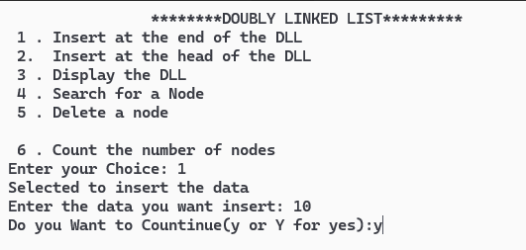

**Displaying:**

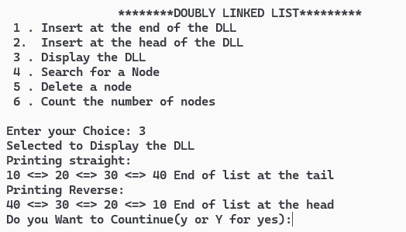

**Inserting at the head:**

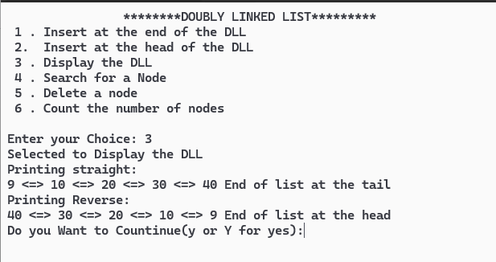

**Searching for the node:**

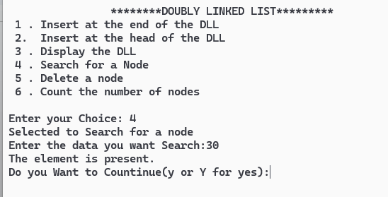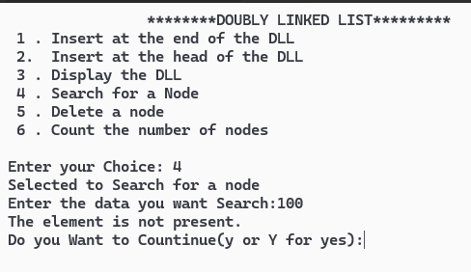

**Counting the number of nodes:**

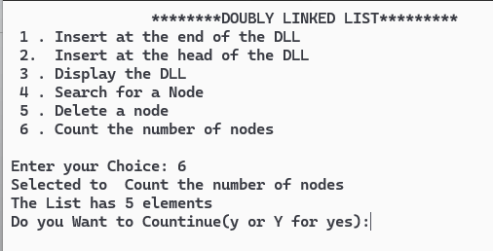

**Delete the node:**

**Deleting head:**

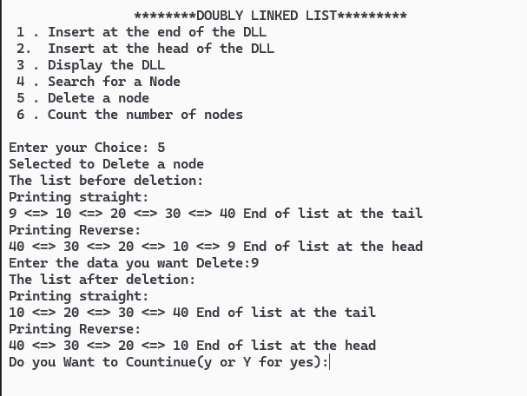

**Deleting tail:**

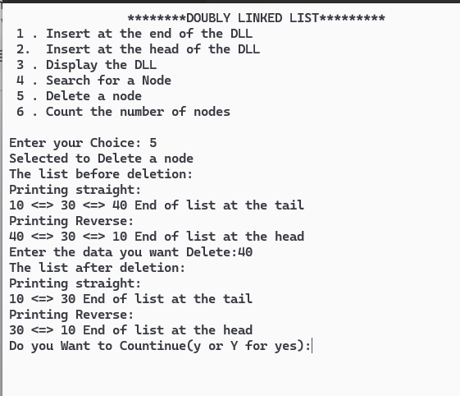

**Deleting middle value:**



**Deleting 1 element:**

